**Implementation of storage equations in MESSAGEix framework**

This document summarizes the concept and equations of the new storage equations that are to be added to the MESSAGEix model. The purpose of this documentation is to provide a simple representation of the concept and equations for illustration and discussion purposes.

**I. Concept of Storage in this Proposal**

The storage concept in this proposal is a generic storage solution that can be used for storing any commodity (e.g., water, heat, electricity, etc.) and shifting that commodity between sub-annual time steps. The storage solution has three distinctive parts:

***- charger:*** a technology for charging a commodity to the storage reservoir, for example, a pump in a pumped hydro power storage (PHS) plant

***- discharger:*** a technology that takes the stored commodity as an input to generate the output commodity, e.g., a turbine in PHS

***- storage container***: a device for storing a commodity over time, such as a water reservoir in PHS

These three technologies and their interlinkage are illustrated in Figure below. In this figure, the levels and commodities are comparable with those of MESSAGEix modeling framework.

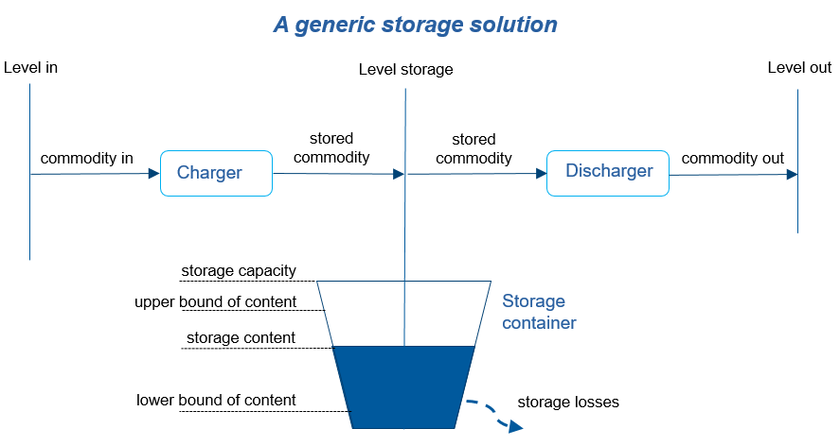Figure 1 Different parts of the storage solution and the terms used in this proposal

The main purpose for proposing this storage configuration with separate charging and discharging technologies is (i) to provide modelers with a full flexibility for parametrization of their storage, and (ii) benefiting from MESSAGEix parameters for controlling the operation of these technologies. It should be noted that the input and output level, and input and output commodity can be the same. The level of storage is excluded from commodity balance in each time step, while the input and output levels are included. The lower and upper bound of storage content as well as storage losses are all presented as percentage of storage capacity in respective equations.

**II. Mathematical Formulation**

The following equations represent the mathematical model suggested for storage implementation in MESSAGEix, and are equivalent of those proposed in the GAMS model. The indexes are the same as those used in the main MESSAGEix model.

The level of storage (“level_storage”) should be specified by the user to exclude this level from COMMODIY_BALANCE equation in the model. Storage container (“storage_tec”) and its respective charger/discharger technologies should also be specified by the user (through “map_storage_tec”). This will link this set of three technologies together in the mathematical model, as there may be several storage solutions connected to the same level or commodity at the same time. For example, a battery and PHS storing electricity at the secondary level can be examined with the equations proposed in this document without the need for making extra commodity or level names.

**II.1. Change in the content of storage (eq. )**

This equation shows the change in the content of storage at each time step. This change can be due to charging (positive) or discharge (negative) in that specific time step.

where , , and are storage container and its linked charger and discharger technologies, respectively.

**II.2. Storage content balance (eq. )**

The content of storage in each time step is equal to the content in the previous time step minus the losses plus storage changes in the current time step. Here, *h* and are two consecutive sub-annual time steps, where .

**II.3. Storage content equality (eq. )**

This equation ensures that the content of storage in the first () and last () sub-annual time step of each period is the same. With this equation, the storage is forced not to create surplus or deficit at the end of each year, compared to content it started with. The first and last period is identified based on the order of sub-annual time steps declared by the user using parameter “time_seq”.

**II.4. Bounds of storage (eq. and )**

These two equations help to limit the maximum and minimum content of storage at desirable time steps. If these two bounds will be set with the same value at a given time step, the content of storage will be forced to that value. These bounds are defined as the percentage of storage container capacity.

The accompanying unit test (a python file under the folder ...\message_ix\tests) is designed for illustrating the functionality of this storage proposal.